TCET - NCC UNIT

The **National Cadet Corps (NCC)** is the youth wing of the Indian Armed Forces, headquartered in New Delhi. It is a voluntary organization open to school and college students across India, operating as a Tri-Services organization that includes the **Army, Navy, and Air Force wings**. The NCC recruits cadets from educational institutions nationwide, providing them with basic military training in small arms, physical fitness, and parade drills. Beyond military training, the NCC emphasizes **personality development, social responsibility and community service, aiming to nurture disciplined, patriotic and united citizens.**

**Motto**: “**Unity and Discipline** **(एकता और अनुशासन)**”, adopted on 23rd December 1957, reflects NCC’s aim to unite youth from across the country and instill **discipline** and **national integration**.

The TCET-NCC Unit was **established in October 2021** with a sanctioned strength of **104 Army Wing Cadets** & **50 Naval Wing Cadets in October 2023.** The unit conducts regular training and activities under the guidance of:

**Cdr. Vijay Pratap Singh** (Mentor & Officer In-charge)

**Lt. (Dr.) Nivant Kambale** (Associate NCC Officer, Army Wing)

**Mr. Sunil Khatri** (Care Taker Officer, Navy Wing)

The TCET-NCC Unit is committed to developing disciplined, responsible and united citizens in line with the NCC motto.



**Mr. Sunil Khatri**

(Care Taker Officer)

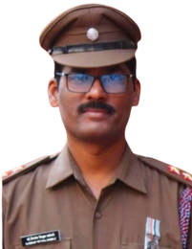

**Lt. Dr. Nivant Kambale**

(Associate NCC Officer)

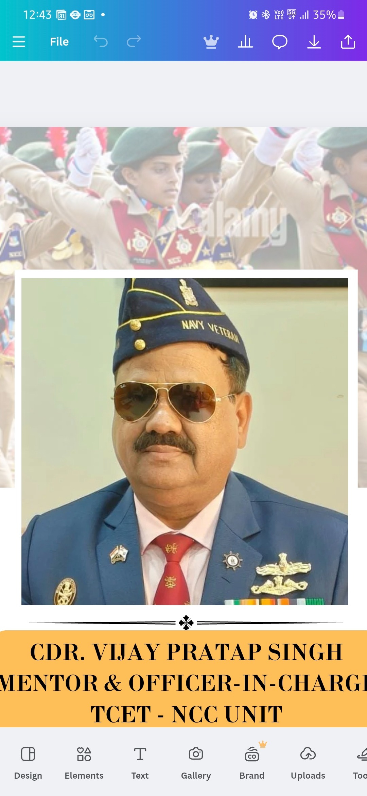

**Cdr Vijay Pratap Singh**

Officer In-charge

**✨ Key Features**

* **✅ First-of-its-kind: Pioneer among private engineering colleges in Maharashtra with official NCC sanction under the Ministry of Defence.**
* **✅ 'C' Certificate Advantage: NCC cadets who successfully earn the ‘C’ Certificate are exempted from the written exam in various Indian Armed Forces recruitment processes.**
* **✅ Prestigious Parade Representation: Outstanding cadets are nominated for Republic Day and Independence Day parades in Mumbai and New Delhi.**
* **✅ Global Exposure: Selected cadets are deputed for international deployments, training programs, and the Youth Exchange Programme (YEP).**
* **✅ Combat Readiness: Hands-on training in small arms and weapon handling conducted by qualified Army personnel.**
* **✅ Holistic Learning: Sessions on national integration, safety, security, and health to instill social awareness and civic responsibility.**
* **✅ Career Mentorship: Periodic motivational lectures and expert guidance on “How to Join the Indian Armed Forces.”**

**🎯 Our Objectives**

**The TCET NCC Unit aims to nurture students into responsible citizens and future leaders, equipped with strength of character and a spirit of service.**

* **🔹 Leadership Development: Create a pool of well-trained, motivated youth who can take up leadership roles across diverse sectors, including defense services.**
* **🔹 Character Building: Foster qualities such as discipline, camaraderie, integrity, and selfless service among cadets.**
* **🔹 Community Engagement: Conduct socially impactful activities to contribute towards community development and national integration.**
* **🔹 Career Facilitation: Provide a structured environment that inspires engineering students to pursue a career in the Indian Armed Forces.**
* **🔹 Adventure & Resilience: Encourage a spirit of adventure, resilience, and secularism through exposure to real-life challenges and collaborative missions.**

**💬 *At TCET NCC, we don’t just train cadets—we inspire a generation committed to serve the nation with honor and pride.***